Main Title

First Author^{1*}, Second Author² & Last Author³ (Use full name for all Author(s))

¹ Affiliation
² Affiliation
³ Affiliation

Keywords:  Keyword 1, keyword 2, keyword 3, keyword 4. | Abstract.  A 250-word paragraph that includes the aims, techniques or primary analysis, and conclusion or main argument makes up the abstract.
* Corresponding author.
E-mail addresses: author@mail.com (Author name).

Section One (14pt, Bold)

In the text, citations are indicated by Smith (1994) or (Smith, 1994, 1995; Jones, 1995), and they are simply enclosed in single brackets. Except in those rare cases where it is required to distinguish between two sets of authors with the same dates, i.e. Smith, Jones, and Brown (1994) and Smith, Green, and White (1994), citations of a work with three or more authors should appear as Smith et al. (1994). (12 points)

To better assure the text's flow, authors should limit the number of footnotes they use—no more than three. Throughout the paper, they must be numbered consecutively, with superior numerals used for numbering outside of punctuation, that is, after the full stop.

Subsection One (12pt, Italic, Bold)
Kindly send tables as editable text rather than picture files. Tables can be positioned at the end of the article on a separate page or next to the pertinent text on the page. Kindly arrange the tables according to their occurrence in the text by numbering them consecutively, and tuck any table remarks beneath the table body. Use tables sparingly, and make sure the information they include doesn't repeat findings that have already been discussed in other sections of the essay. Below is an example of a table format.

Table 1: Variables’ Summary Statistics (12pt)
XYZ | XYZ | XYZ | XYZ | XYZ | XYZ | XYZ | XYZ
A | 1 | 0.000 | 0.000 | 0.000 | 0.000 | 0.000 | 0.000
 | 2 | 0.000 | 0.000 | 0.000 | 0.000 | 0.000 | 0.000
B | 1 | 0.000 | 0.000 | 0.000 | 0.000 | 0.000 | 0.000
 | 2 | 0.000 | 0.000 | 0.000 | 0.000 | 0.000 | 0.000
 | 3 | 0.000 | 0.000 | 0.000 | 0.000 | 0.000 | 0.000
C | 1 | 0.000 | 0.000 | 0.000 | 0.000 | 0.000 | 0.000
 | 2 | 0.000 | 0.000 | 0.000 | 0.000 | 0.000 | 0.000
 | 3 | 0.000 | 0.000 | 0.000 | 0.000 | 0.000 | 0.000
Note: The table notice ought to be placed at the base of the table. Table notes shouldn't be more than two lines. (10pt)

Subsection
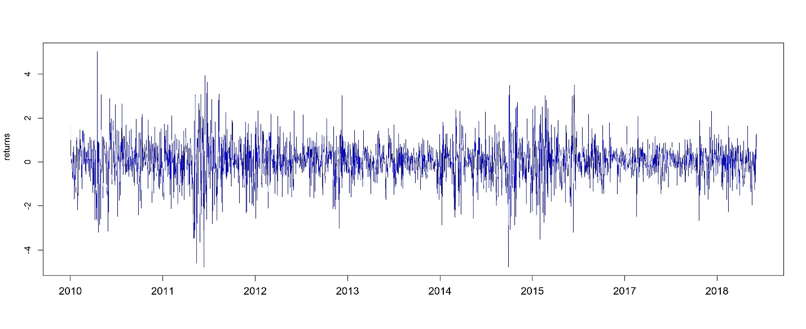
Figure I: Details (12pt)

Section Two
Equations ought to be written on distinct lines and numbered (1), (2), and so on on the right. Except for differential d, exponential e, cos, sin, lim, and so on, which are conventional roman notations, all mathematical notations should be italic. Math equations should be sent as editable text, not as pictures. An example of an equation format is as follows:
(1)

Declaration (14pt, Bold)
I, [Your Full Name], hereby confirm that the manuscript titled "[Title of the Paper]" authored by [Author(s) Full Name(s)], has not been submitted for publication, review, or consideration to any other journal, conference, or publication venue.
I affirm that this work is original and is not under consideration elsewhere. All the authors listed have approved the manuscript and agreed to its submission to [Name of the Journal/Conference].
I/we declare that all necessary permissions have been obtained for any third-party materials included in the manuscript, and appropriate citations and acknowledgments have been made where required.

References (14pt, Bold)

Journal paper with one author:
Holder, M. (2009). The contribution of social relationships to children’s happiness.
Journal of Happiness, 10(3), 329-349.
Journal Paper with two authors:
Arellano, M., & Bond, S. (1991). Some tests of specification for panel data: Monte Carlo evidence and an application to employment equations. Review of Economic Studies, 58(2), 277-297.
Journal Paper with three authors:
Andersson, L. F., Eriksson, L., & Lindmark, M. (2010). Life insurance and income growth: the case of Sweden 1830–1950. Scandinavian Economic History Review, 58(3), 203-219.
Journal Paper with three authors and DOI:
Chang, T., Lee, C. C., & Chang, C. H. (2014). Does insurance activity promote economic growth? Further evidence based on bootstrap panel Granger causality test. The European Journal of Finance, 20(12), 1187-1210. doi: 10.1080/1351847X.2012.757555
Working Paper:
Catalan, M., Impavido, G. and Musalem, A. R. (2000), “Contractual Savings or Stock Market Development- Which Leads”, Unpublished Policy Research Working Paper. No. 2421. The World Bank, Washington DC.
Paper in Edited Volume:
Wasow, B., & Hill, R. D., (1986). Determinants of Insurance Penetration: A Cross-Country Analysis. In B. Wasow & R. D. Hill (Eds.), Insurance Industry in Economic Development (pp. 160-176). New York, NY: New York University Press.
Conference Paper:
Guochen, P., & Wei, S. C., (2012, July 18-21). The Relationship between Insurance Development and Economic Growth: A Cross-Region Study for China. Paper presented at 2012 China International Conference on Insurance and Risk Management, held at Qingdao, China.
-----------------------------------------------------------------------------------------
IN-TEXT CITATIONS
Basic format for using quotations, summarizing, and paraphrasing
Schlosser (2002) believes that “the twenty-first [century] will no doubt
be marked by a struggle to curtail excessive corporate power” (p.104).

Since 1987 the British government has been concerned about the
possibilities of a tainted meat supply (Schlosser, 2002, p.84).
(David and Meuleman, 2012)
(Swaroglou, Delpierre and Dernelle, 2004; Schwartz and Huisman, 1995),

